*Q1)*

Find the DOF using Grubler’s formula

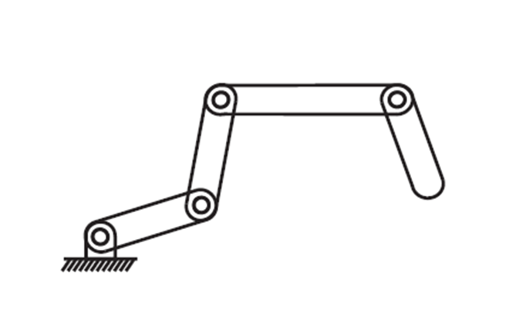

N = 5

J = 4

DOF = 3\*(5-1-4) + 4 = 4